OPERATING SYSTEM PROJECT

SOCKET PROGRAMMING IN C

Instructor

Ms. Anaum Hamid

Course

CS-2006

Section

BCS-4J

Group Members

Qasim Hasan (21k-3210)

Ahsan Ashraf (21k-3186)

Kantesh kumar (21k-3426)

Features Implemented in Project:

MAIN FEATURE:

1. Group Chat Application (Multithreaded/Multiple Clients)

SUB FEATURES:

1. Single client server Interaction
2. Client/Server File Transfer
3. Client/Server Calculator

Tools and Technology, Languages and Utilities:

  

GitHub Link and QR-Code:



<https://github.com/pkcoder420>

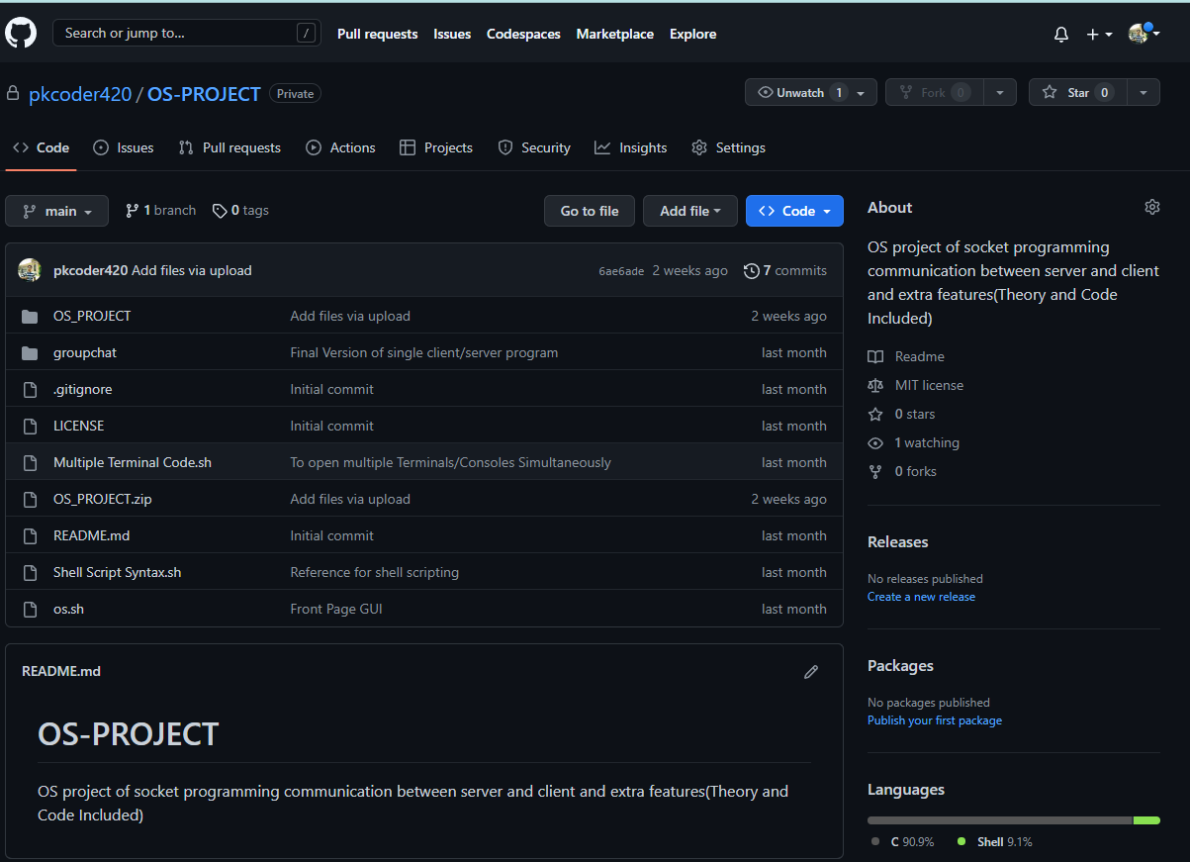

Objective:

We gave 4 programs each program consisting of two c files one has a server and the other has a client. We are using socket function defined in c using multiple libraries which are explained below.

Our goal was to enable communication between client and user, test various scenarios between them, and enable numerous clients to connect to a server and talk across a socket while it is actively taking requests.

Here we are simulating two pc as two terminals.

Libraries:

Following are the libraries we used in our C programs.

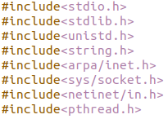

|  |  |
| --- | --- |
| stdio.h | This header file contains declarations for input and output in all c programs. |
| stdlib.h | Defines Variable types, several macros and functions. Ex: int atoi(const char*) |
| unistd.h | Provide access to Posix API. |
| string.h | All functionality regarding strings.  Len() , concatenate() e.tc |
| Arpa/inet.h | Contains definitions for internet operations.(For windows winsock) |

|  |  |
| --- | --- |
| sys/socket.h | Definitions for structures needed for sockets. Ex: sockaddr |
| netinet.h | Constants and structures needed for internet domain address ex sockaddr_in |
| pthread.h | Give us access to make multiple threads so we can give access to multiple users/clients |

State Diagram of Server and Client Model:

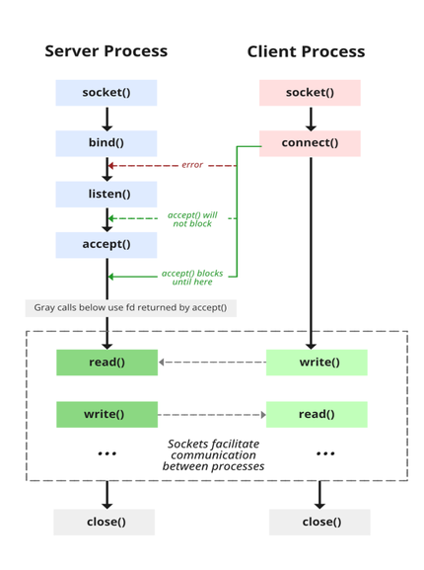

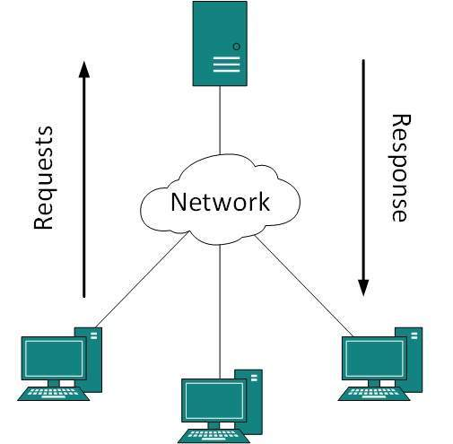

1. Socket Creation:

int sockfd = socket (domain, type, protocol)

**sockfd:** socket descriptor, an integer (like a file-handle)

**domain:** integer, specifies communication domain. We use AF_ LOCAL as defined in the POSIX standard for communication between processes on the same host. For communicating between processes on different hosts connected by IPV4, we use AF_INET and AF_I NET 6 for processes connected by IPV6.

**type:** communication type

**SOCK_STREAM:** TCP (reliable, connection oriented)

**SOCK_DGRAM:** UDP (unreliable, connectionless)

protocol: Protocol value for Internet Protocol(IP), which is 0. This is the same number which appears on protocol field in the IP header of a packet. (man protocols for more details)

1. Bind:

int bind (int sockfd, const struct sockaddr *addr, socklen_t addrlen);

After the creation of the socket, the bind function binds the socket to the address and port number specified in addr (custom data structure). In the example code, we bind the server to the localhost, hence we use INADDR_ANY to specify the IP address.

1. Listen:

int listen (int sockfd, int backlog);

It puts the server socket in a passive mode, where it waits for the client to approach the server to make a connection. The backlog, defines the maximum length to which the queue of pending connections for sockfd may grow.

1. Connection:

int connect (int sockfd, const struct sockaddr *addr, socklen_t addrlen);

**Socket connection:** Exactly same as that of server’s socket creation

**Connect:** The connect () system call connects the socket referred to by the file descriptor sockfd to the address specified by addr. Server’s address and port is specified in addr.

1. Accept:

int new_socket= accept (int sockfd, struct sockaddr *addr, socklen_t *addrlen);

It extracts the first connection request on the queue of pending connections for the listening socket, sockfd, creates a new connected socket, and returns a new file descriptor referring to that socket. At this point, the connection is established between client and server, and they are ready to transfer data.

MANUAL FOR COMPILING AND RUNNING PROGRAMS:

1. RUN THE PROJECT:

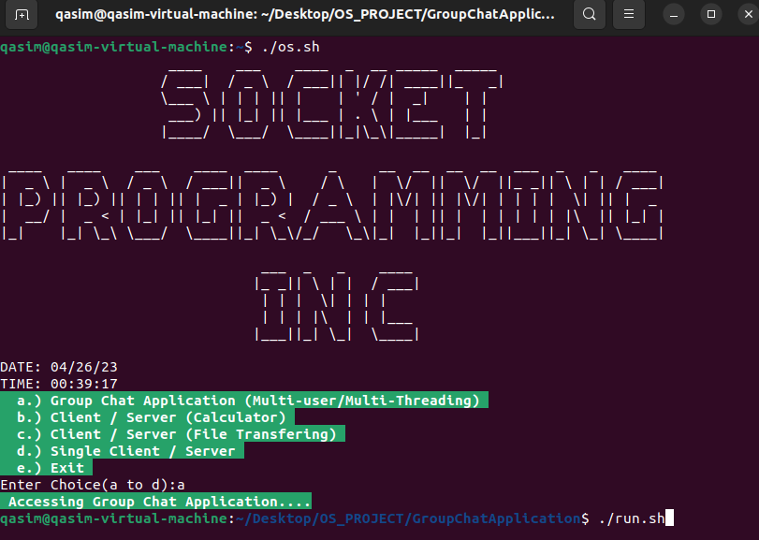

1. Compile and Run Multi-Chat Program:

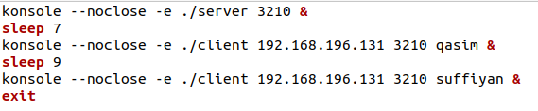

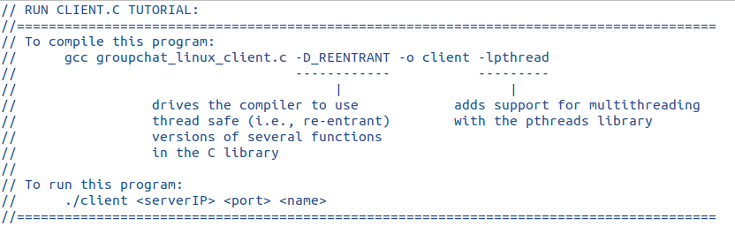

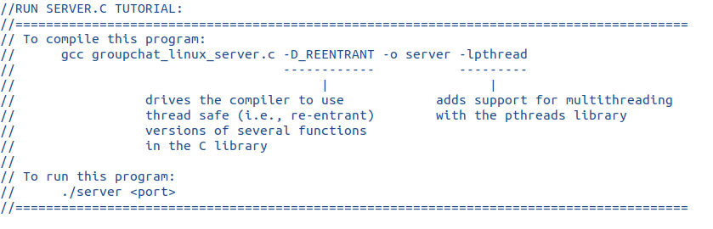

1. Compile and Run Single Client/Server Program:

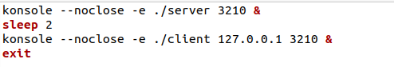

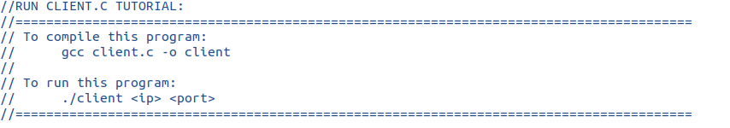

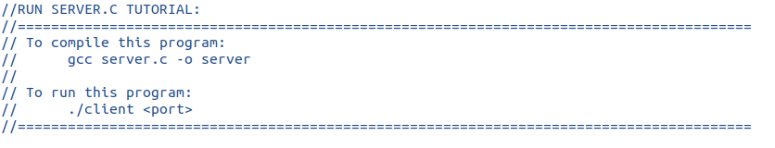

1. Transfer File:
2. Calculator:

EXPLANATION OF CODE (C language):

***MULTI CHAT SERVER AND CLIENT (MAIN CODE)***

**Server:**

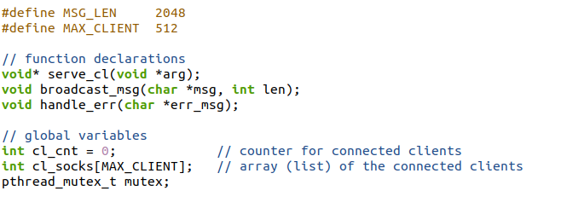

The code above defines the global variables **cl_cnt, cl_socks**, and **mutex**, as well as three function prototypes named **serve_cl, broadcast_msg,** and **handle_err.**

* The **cl_cnt** variable is an integer that is used to keep track of the number of connected clients.
* The **cl_socks** variable is an array of integers with a maximum size of **MAX_CLIENT** (which is defined to be 512) that is used to store the socket descriptors of all connected clients.
* The **mutex** variable is a pthread **mutex** that is used to synchronize access to the shared resources of the server, such as the **cl_cnt** and **cl_socks** variables.

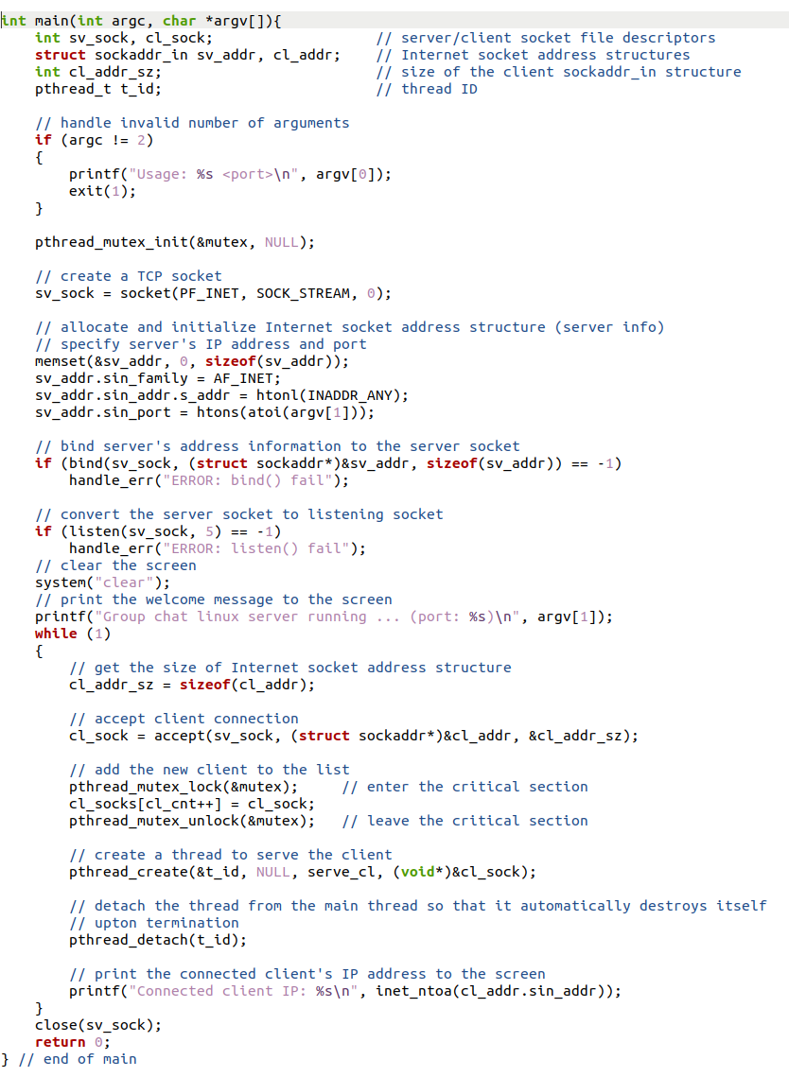

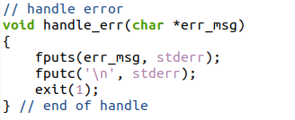

This is the main function of a Linux server for a group chat application. It sets up the server socket and accepts incoming client connections, adding each connected client to a list of connected clients. The server creates a new thread to serve each connected client and detaches the thread from the main thread so that it can automatically destroy itself upon termination.

The main function first declares the necessary variables, including socket file descriptors, Internet socket address structures, and a thread ID. It then checks the number of command-line arguments and prints an error message if the number is not equal to two.

* The function initializes a mutex for synchronization purposes using pthread_mutex_init(). A TCP socket is then created using socket(). The function then initializes the server's Internet socket address structure by allocating memory and setting its attributes, including the server's IP address and port number. The server's address information is then bound to the server socket using bind(). If this operation fails, the handle_err() function is called to handle the error.
* The function then converts the server socket to a listening socket using listen(). If this operation fails, the handle_err() function is called to handle the error.

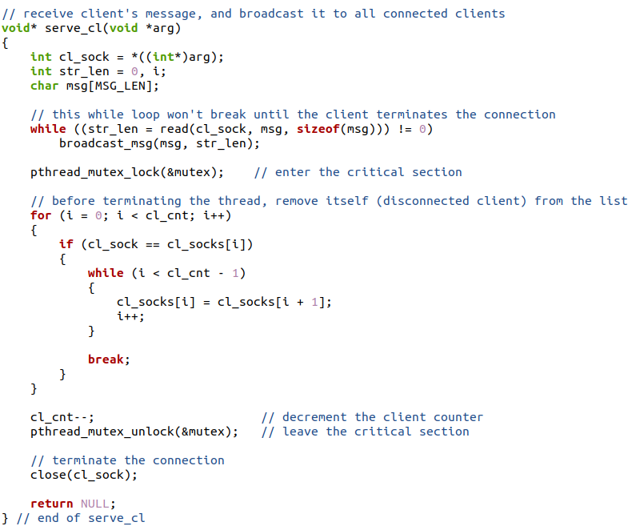

The serve_cl function is the function that is executed in a separate thread to handle communication with a single client. Here is a breakdown of the code:

The function takes in a void pointer argument arg, which is cast to an integer and dereferenced to obtain the socket file descriptor of the client.

* The function then declares some variables, including an integer variable str_len to store the length of the message received from the client, an integer variable i for looping through the array of connected clients, and a character array msg to store the message received from the client.
* The function enters a while loop, which reads data from the client using the read function. If the length of the message received is zero, that means the client has terminated the connection, so the loop breaks.
* The message received from the client is then broadcast to all connected clients using the broadcast_msg function.
* After the while loop, the function enters a critical section by acquiring the mutex lock using pthread_mutex_lock. The function then searches for the disconnected client's socket file descriptor in the array of connected clients and removes it from the list. This is done to keep track of the number of connected clients accurately.
* The function then decrements the cl_cnt variable, which keeps track of the number of connected clients.The mutex lock is then released using pthread_mutex_unlock.Finally, the function terminates the connection with the client using the close function and returns NULL.

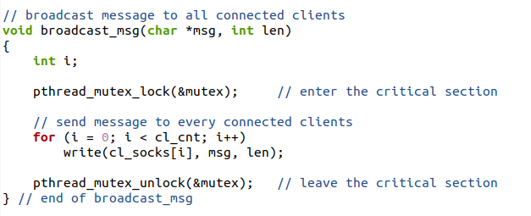

The function broadcast_msg is responsible for broadcasting a message to all connected clients. The function takes two arguments: msg, a character pointer that holds the message to be sent, and len, an integer representing the length of the message.

* The function first enters a critical section by acquiring the mutex lock, to ensure mutual exclusion and prevent multiple threads from accessing the shared resources (client sockets) at the same time. Then, it loops through all the connected clients' sockets in the cl_socks array and sends the message to each of them using the write function. After sending the message to all connected clients, the function leaves the critical section by releasing the mutex lock.
* The function assumes that all clients' sockets are valid and connected to the server. If there are any connection issues, the error needs to be handled appropriately in the serve_cl function, which is responsible for removing the disconnected client's socket from the cl_socks array.

**Client:**

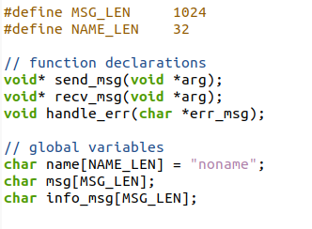

The code above is a set of preprocessor directives and function declarations, as well as global variable declarations.

* #define MSG_LEN 1024 defines a macro constant MSG_LEN with a value of 1024.
* #define NAME_LEN 32 defines a macro constant NAME_LEN with a value of 32.
* void* send_msg(void *arg); is a function declaration for a function called send_msg that takes a void pointer argument and returns a void pointer.
* void* recv_msg(void *arg); is a function declaration for a function called recv_msg that takes a void pointer argument and returns a void pointer.
* void handle_err(char *err_msg); is a function declaration for a function called handle_err that takes a character pointer argument and returns nothing.
* char name[NAME_LEN] = "noname"; is a global variable declaration that creates an array of characters called name with a length of NAME_LEN (32) and initializes it with the string "noname".
* char msg[MSG_LEN]; is a global variable declaration that creates an array of characters called msg with a length of MSG_LEN (1024).
* char info_msg[MSG_LEN]; is a global variable declaration that creates an array of characters called info_msg with a length of MSG_LEN (1024).

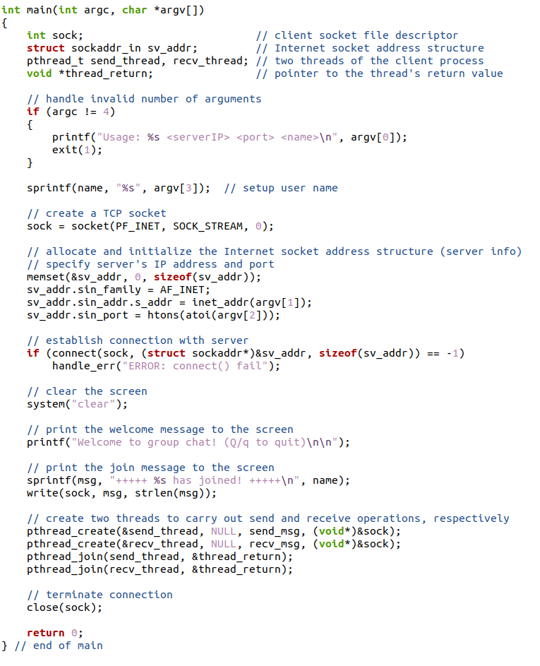

This is the main function of a simple chat client that connects to a server using TCP sockets and carries out communication through two threads: one for sending messages and another for receiving messages.

* The main function takes three command-line arguments: the IP address of the server, the port number of the server, and the name of the client user. If the number of arguments is not three, it prints the usage message and exits with an error code.
* Then, the client creates a TCP socket using the socket system call, and initializes the Internet socket address structure with the IP address and port number of the server. The client then establishes a connection with the server using the connect system call.
* After connecting to the server, the client clears the screen and prints a welcome message to the user. It also sends a message to the server indicating that the user has joined the chat room.
* The client then creates two threads using the pthread_create system call, one for sending messages and another for receiving messages. The client also waits for the threads to finish using the pthread_join system call.
* Finally, the client terminates the connection with the server using the close system call and exits with a success code.

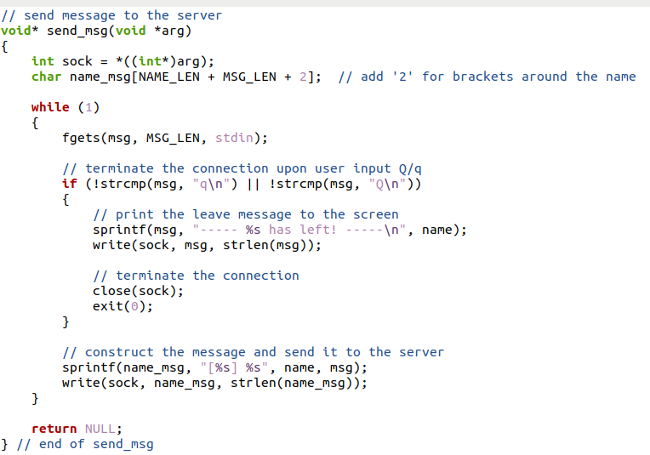

* This function send_msg is responsible for sending messages to the server. It takes a void pointer arg as its argument, which is a pointer to the integer file descriptor of the client socket. Inside the function, it first initializes a character array name_msg of size NAME_LEN + MSG_LEN + 2, which will be used to store the message that includes the user's name.
* It then enters an infinite loop where it waits for the user to input a message using fgets and stores it in the msg character array of size MSG_LEN. If the user inputs q or Q, it sends a leave message to the server with the user's name and terminates the connection by closing the socket and exiting the program.
* If the user inputs any other message, it constructs the final message by appending the user's name to the input message inside the name_msg character array, enclosed in square brackets. Finally, it sends the message to the server using the write function. The function returns NULL at the end.

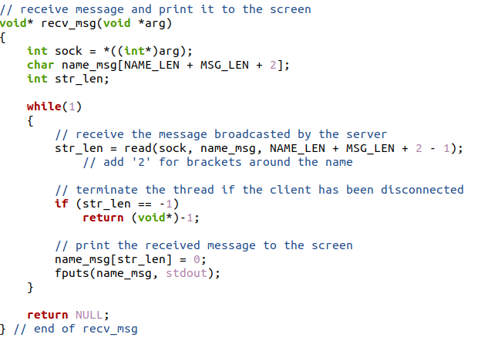

This code defines a function recv_msg that is intended to be run as a separate thread in a client-server chat application. The function receives messages from the server and prints them to the screen.

* The function starts by extracting the client socket file descriptor from the argument passed to it. Then, in a continuous loop, the function reads messages from the server using the read() function. The read() function reads up to NAME_LEN + MSG_LEN + 2 - 1 bytes of data from the socket (sock) and stores them in the buffer name_msg. The NAME_LEN and MSG_LEN constants define the maximum length of the username and message, respectively, and the 2 is added to account for the square brackets that are added to the message later.
* If the read() function returns -1, it means that the client has been disconnected from the server, and the function returns -1 as well.Otherwise, the received message is printed to the screen using the fputs() function.
* The name_msg buffer is null-terminated by setting the character at str_len to 0 before it is printed. Finally, the function returns NULL.

***Terminal Code:***

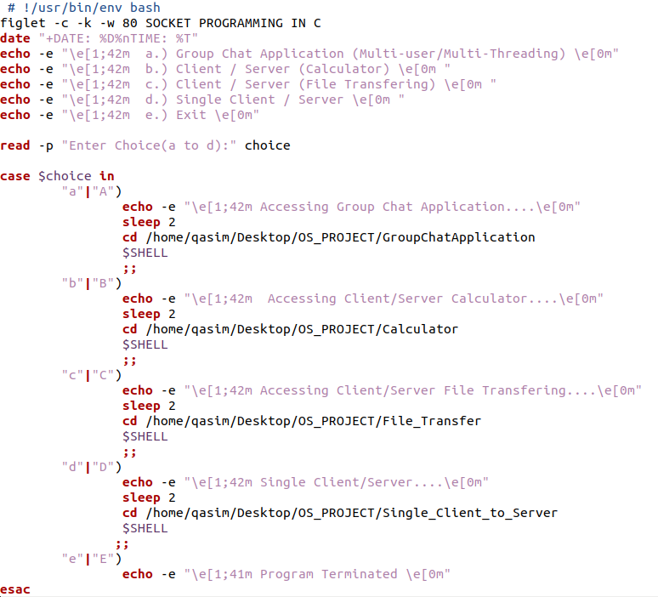

Here we have use basic shell script code and used figlet library to give our terminal some personality and make the project presentable.

***CONCLUSION AND LIMITATION:***

**REFERENCES:**

MULTICHAT SERVER/CLIENT:

<https://www.youtube.com/watch?v=KEiur5aZnIM&t=1482s>

<https://www.youtube.com/watch?v=fNerEo6Lstw&t=1160s>

SINGLE CLIENT/SERVER:

<https://www.youtube.com/watch?v=CMDBF84vSRk&list=PLPyaR5G9aNDvs6TtdpLcVO43_jvxp4emI&index=4>

FILE TRANSFER:

<https://www.youtube.com/watch?v=9g_nMNJhRVk&list=PLPyaR5G9aNDvs6TtdpLcVO43_jvxp4emI&index=8>

CALCULATOR:

<https://www.youtube.com/watch?v=cBNabLJH_cw&list=PLPyaR5G9aNDvs6TtdpLcVO43_jvxp4emI&index=7>

THEORY:

<https://www.youtube.com/watch?v=uHqPzNg_0OE&list=PLAZj-jE2acZKojAI_5Xwt897uzYazWC7w>

<https://www.youtube.com/watch?v=quH5i50lLOY&list=PLPyaR5G9aNDvs6TtdpLcVO43_jvxp4emI&index=2>

<https://www.youtube.com/watch?v=b_TUtu3PemQ&list=PLPyaR5G9aNDvs6TtdpLcVO43_jvxp4emI&index=3>

THANK YOU for more information contact me at my GitHub given or at my Work Gmail [k21321@nu.edu.pk](mailto:k21321@nu.edu.pk) or personal mail [qasimhasanbilgrami1@gmail.com](mailto:qasimhasanbilgrami1@gmail.com)